Bug Tracking system

Problem statement

Inefficient Issue Management and Quality Assurance in Software Development

In modern software development, maintaining high-quality applications is paramount. However, our current processes for identifying, tracking, and resolving software issues, including bugs, defects, enhancements, and feature requests, are inadequate. This leads to reduced software quality, missed deadlines, and inefficient development and testing teams.

Objectives

1. Develop a comprehensive Bug Tracking System that streamlines the issue management process.
2. Enable efficient issue reporting and tracking, eliminating manual and error-prone methods.
3. Facilitate collaboration among teams through a centralized platform.
4. Enable access management for security

Proposed Solution

A Bug Tracking System (BTS) is a crucial component of software development and quality assurance processes. It helps teams identify & report bugs, prioritize & track tasks and resolve issues or bugs in software applications

Primary objectives of any Bug Tracking System are:-

**Issue Management:** Efficiently track and manage software issues, including bugs, defects, enhancements, and new feature requests.

**Improved Collaboration:** Facilitate collaboration among development, testing, and product management teams to ensure effective bug resolution.

**Quality Assurance:** Enhance the overall software quality by systematically identifying and addressing issues.

**Reporting and Analytics:** Provide insights into the health of the software through reporting and analytics on issue trends, resolution times, and more.

Flow Diagram

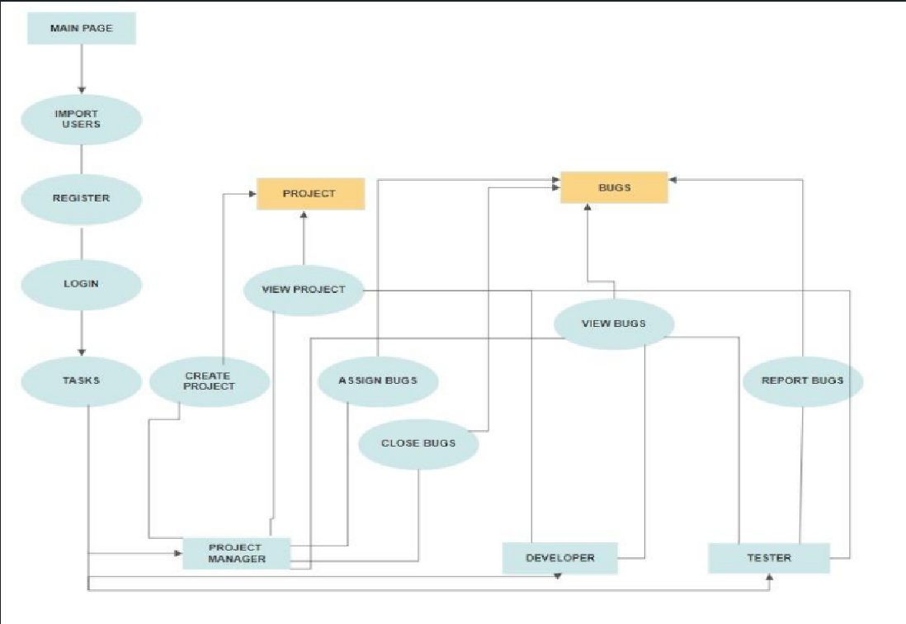

ER Diagram

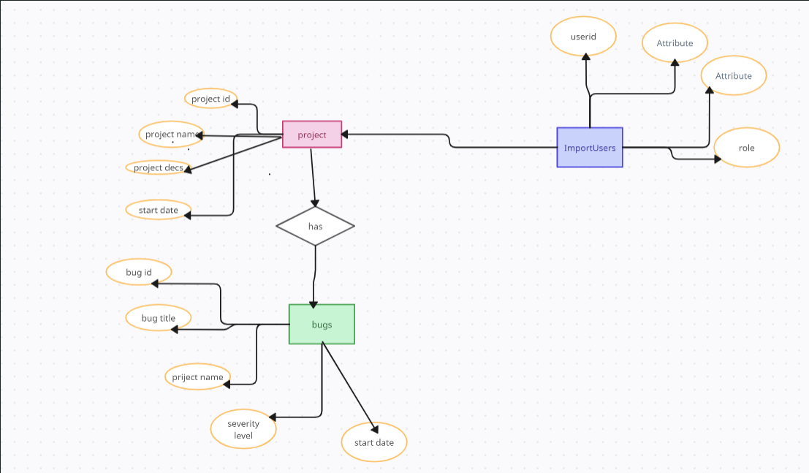

Class Diagram

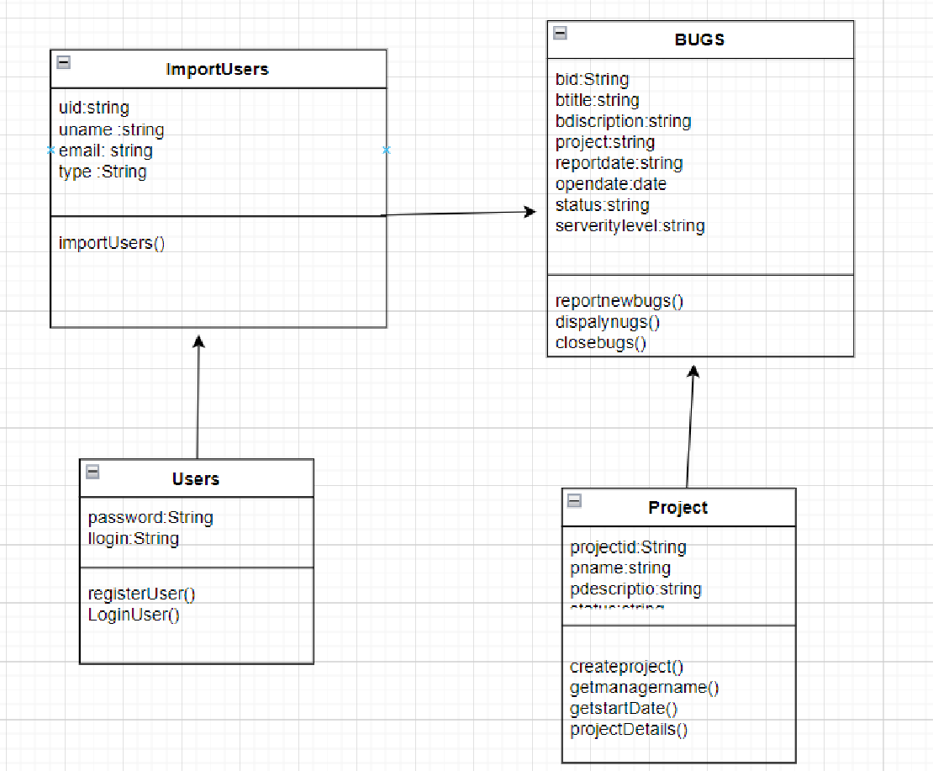

Modules

Import Users

* This module provides a form to import a file containing user information into the system

Registration

* This module allows a user that has been imported to register with the system and generate a password

Login

* This module allows a user to login who has been registered.

Project Manager

* Create a new project and manages the projects
* Assign team members to a project
* Views all the bugs and assigns the bugs to the developers and closes the bugs

Tester

* Views the list of projects
* Views the list the bugs assigned to each project by the project manager
* Reports a new bug

Developer

* Views the details of the project which is assigned
* Mark a bug for closing

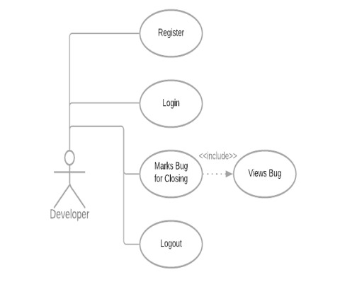

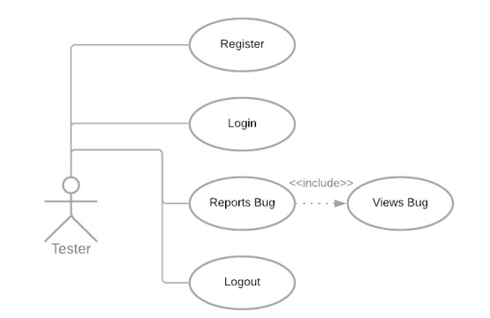

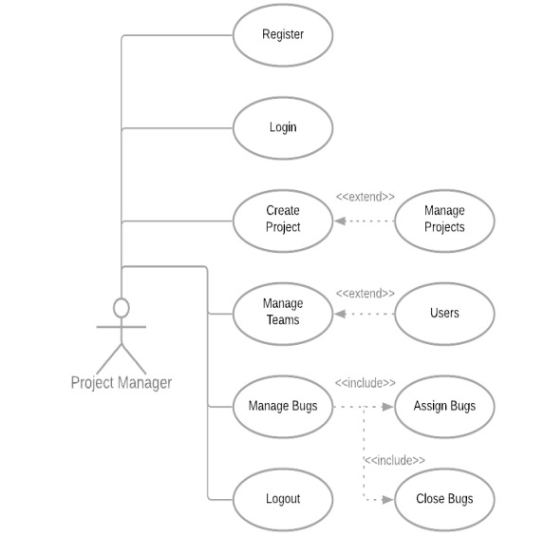

FUTURE SCOPE

In the future, we will move from the current prototype of the interactive system to a full-scale system that can deal with a variety of information to gather, as commonly observed in the real world.

Current bug tracking systems do not effectively elicit all of the information needed by developers. Without this information developers cannot resolve bugs in a timely fashion and so we believe that improvement to the way bug tracking systems collect information are needed.

CONCLUSION

A software bug occurs when an application or program doesn’t work the way it is designed to function. Most errors are faults or mistakes made by system architects, designers or developers. Testing teams use bug tracking to monitor and report on errors that occur as an application is developed and tested. The proposed Bug Tracking system is a great application with software development needs. By using the Bug Tracking Software one can eliminate bugs in their project effectively as it contains all the necessary information required by the developers to resolve the issue. This application will definitely increase communication between the team members and improve customer satisfaction and efficiency